

BAHÇEŞEHIR CYPRUS UNIVERSITY

FACULTY OF ARCHITECTURE AND ENGINEERING

ELECTRICAL AND ELECTRONICS ENGINEERING

PROJECT ENGINEERING REPORT
SPEECH TO TEXT DEVICE USING ESP32

Course code & name: EEE3101 Microcontrollers

Malikov Kutman (ID: 32300128)

Project Advisor: Abdallah El Mohammed Merhebi

Abstract

This project presents the design and implementation of a standalone speech-to-text translation system using the ESP32 microcontroller. The device captures spoken input through a digital I2S microphone, processes the audio, and performs automatic transcription and translation using cloud-based APIs. The primary goal of this work is to develop an embedded system capable of converting speech into a translated text output with minimal user interaction and low hardware complexity.

The system employs an INMP441 microphone connected via the I2S interface and an ILI9341 TFT display for user interaction. Audio signals are recorded and saved locally as 16-bit WAV files in LittleFS storage through a custom recording module. Once recording is complete, the file is uploaded to the ElevenLabs Speech-to-Text API, which transcribes the audio into text. The transcribed text is then processed by the DeepL Translation API to produce a translated output, which is displayed directly on the TFT screen. Only the final translated text is shown to the user to maintain simplicity and clarity of output.

A number of technical issues were solved throughout the development process, such as Wi-Fi reconnection handling, ESP32 stability under high memory load, and microphone noise reduction. The final product demonstrates accurate multilingual translation, reliable audio capture, and stable operation. The results demonstrate the potential of carrying out challenging voice recognition and translation tasks on a small, inexpensive embedded device.

Contents
Abstract 2
Introduction 4
Methods and results 5
Hardware 6
Hardware Connections 6
ESP32 Microcontroller 7
INMP441 Digital Microphone 8
ILI9341 TFT Display 9
Push Button (Recording Control) 10
Summary for hardware 11
Software 11
Software Architecture Overview 11
MicrophoneHandler 12
AudioRecorder 13
WiFiFunc 14
ElevenLabsSTT 15
Translator (DeepL API) (Addition) 16
DisplayHandler 17
Main Program Logic 17
Summary for software 18
Results 19
Discussion 19
General Evaluation 19
Design Decisions 20
System Performance and Stability 20
Limitations 21
Future Improvements 21
Conclusion 21

Introduction

Speech recognition has become one of the most significant developments in modern embedded systems, enabling machines to interpret and respond to human language. With the growing use of smart assistants, automated translation tools, and hands-free control systems, speech-to-text technologies have become increasingly relevant in both consumer and industrial applications. Despite these advances, most existing systems rely on high-end processors or cloud-based infrastructures, which are often costly and unsuitable for low-power microcontroller platforms.

The main purpose of this project is to design and implement a speech-to-чtext translation device using the ESP32 microcontroller. The system is intended to capture human speech through a digital microphone, convert the recorded sound into text using an online speech recognition engine, translate the recognized text into another language, and display the translated output on a small TFT screen. This project demonstrates that complex speech-processing and translation tasks can be executed effectively using limited embedded resources.

The scope of the work focuses on the integration of hardware and software components necessary to achieve the complete speech-to-translation pipeline. The hardware includes an ESP32 development board, an INMP441 digital I2S microphone, and an ILI9341 TFT display. The software is based on modular C++ code implementing separate modules for audio capture, file recording, Wi-Fi management, cloud communication, and display control. Cloud services from ElevenLabs and DeepL are utilized for speech transcription and translation respectively.

The development plan was structured into three main stages:
- Implementation of audio capture and recording using the I2S interface.
- Integration of cloud-based speech recognition and translation APIs.
- Optimization of stability, memory management, and user interface performance.
In conclusion, this project validates that a low-cost embedded microcontroller can successfully perform real-time speech acquisition, cloud-based processing, and multilingual translation. It provides a foundation for future research on portable voice-activated devices and intelligent human–machine interfaces.

Methods and results

This section describes the methods applied during the design and implementation of the Speech-to-Text Translation System and presents the obtained results. It explains both the hardware and software components of the device in detail, covering how each module operates and how they interact to achieve the desired functionality. The section also outlines the algorithms used for audio processing, cloud communication, and data handling, followed by the observed performance of the final prototype.

Hardware

The hardware of the Speech-to-Text Translation System is composed of five primary components: the ESP32 microcontroller, the INMP441 digital microphone, the ILI9341 TFT display, a push button used for recording control, and the power supply circuitry. Each component was selected to ensure low power consumption, reliability, and full compatibility with the ESP32 development environment.

Hardware Connections
Component | Signal | ESP32 Pin | Peripheral Pin | Description
INMP441 (Microphone) | BCLK / SCK | GPIO32 | SCK | I2S Bit Clock signal
 | LRCLK / WS | GPIO25 | WS | Word Select (right channel only)
 | DOUT / SD | GPIO33 | SD | Serial audio data output
 | L/R Select | GND | L/R | Grounded → Right channel mode
 | VCC | 3.3 V | VDD | Power supply
ILI9341 Display (SPI) | MOSI | GPIO23 | SDI (MOSI) | Serial data input
 | MISO | GPIO19 | SDO (MISO) | Serial data output (optional)
 | SCK | GPIO18 | SCK | SPI clock
 | CS | GPIO15 | CS | Chip Select
 | DC | GPIO2 | DC | Data/Command control
 | RESET | GPIO4 | RESET | Hardware reset line
 | VCC | 5 V | VCC | Power input (module has regulator)
Push Button | — | GPIO34 | — | Active-low input (pressed = LOW)
Power Supply | — | USB 5 V | — | Powers ESP32 and peripherals
 | — | 3.3 V | INMP441 VCC | Mic power output

ESP32 Microcontroller
The ESP32 DevKit V1 microcontroller serves as the central processing unit of the system. It is a dual-core, 32-bit MCU equipped with built-in Wi-Fi and sufficient Flash memory to host both firmware and local storage. The device provides native I2S and SPI peripherals, which are essential for audio acquisition and display communication respectively.

The ESP32 was selected because it provides a balanced trade-off between performance and power consumption, supporting simultaneous network communication and signal processing. The built-in FreeRTOS scheduler is utilized for background Wi-Fi monitoring tasks, while the main core handles audio processing and user interface updates. The microcontroller operates at 3.3 V logic, ensuring compatibility with the INMP441 microphone and TFT display.
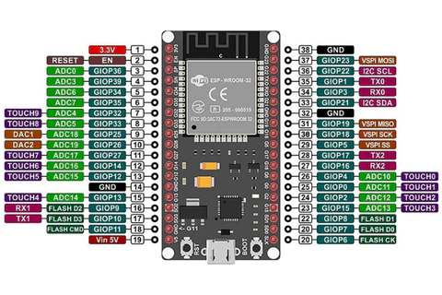

INMP441 Digital Microphone
The INMP441 is a high-performance, omnidirectional digital microphone based on the I2S communication protocol. Unlike analog microphones, it directly outputs a digital signal, eliminating the need for an analog-to-digital converter. The device generates 24-bit audio samples synchronized by two timing signals: BCLK (bit clock) and LRCLK/WS (word select).

In this project, the microphone is configured to transmit only the right channel, since the INMP441 produces a single channel of audio data. The output bitstream is captured through the ESP32’s I2S peripheral and processed in real time by the MicrophoneHandler module. The I2S sampling rate is set to 16 kHz, which provides sufficient fidelity for speech recognition while minimizing memory usage. The choice of INMP441 was motivated by its low noise level, compact size, and compatibility with 3.3 V logic.

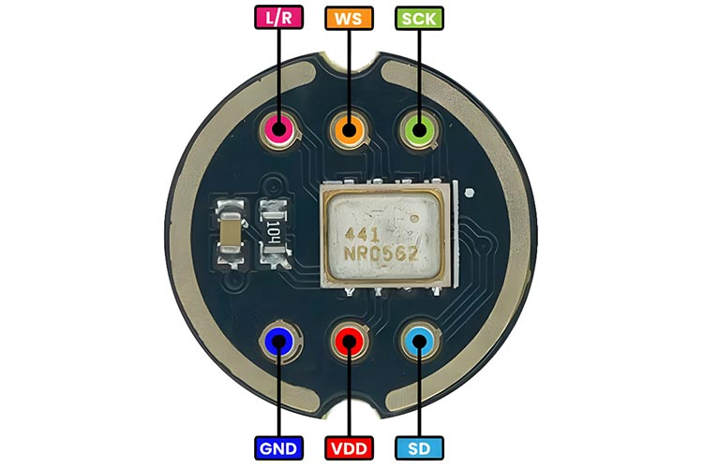

ILI9341 TFT Display
The ILI9341 display is a 3.2-inch TFT (Thin Film Transistor) module that communicates with the ESP32 via the SPI interface. It operates at 240×320 pixel resolution and supports full 16-bit color depth. The display is managed by the DisplayHandler software module using the Adafruit_ILI9341 and Adafruit_GFX libraries.

The display is responsible for visual output, showing system states such as Wi-Fi connecting, Recording, Processing, and Translation completed. The final translated text is rendered on screen with line wrapping for readability. The ILI9341 was chosen for its robust community support, high refresh rate, and direct compatibility with ESP32 SPI hardware. A 5 V supply is used since the module includes an onboard voltage regulator converting it to 3.3 V internally.
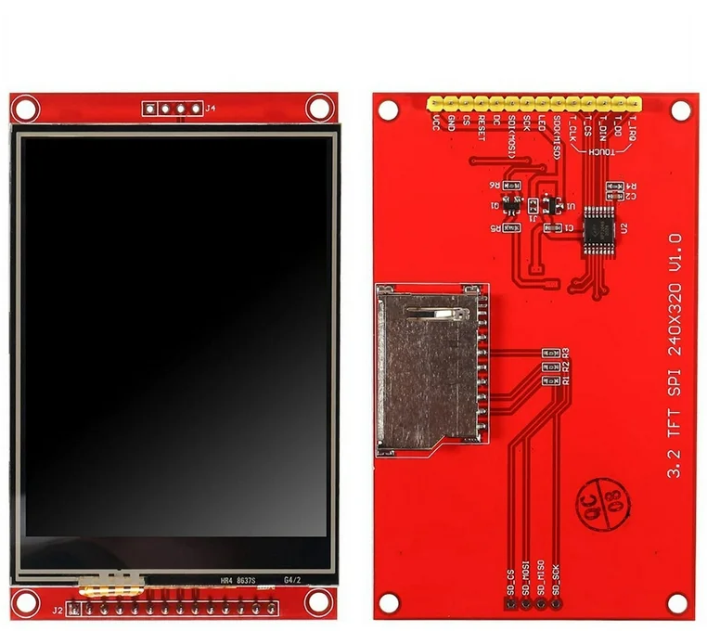

Push Button (Recording Control)
A single momentary push button connected to GPIO34 is used to control the recording process. The logic is active-low: when the button is pressed, the pin reads LOW, initiating audio recording; when released, the pin returns to HIGH, stopping the recording and triggering the speech-to-text and translation sequence.

Since GPIO34 is an input-only pin on the ESP32, it is ideal for this function. A pull-up resistor keeps the pin high by default, while internal software debouncing ensures stable operation. This configuration minimizes power consumption and avoids false triggers due to signal noise.

Summary for hardware
The hardware configuration ensures that the ESP32 microcontroller can efficiently handle both digital audio acquisition and network communication without external components. The use of the INMP441 microphone simplifies the design by eliminating analog circuitry, while the ILI9341 display provides a clear interface for user feedback. The result is a compact and energy-efficient embedded system capable of speech recognition and translation in real time.

Software

The software of the system is developed in C++ using the PlatformIO environment and structured into several modular components. Each module performs a specific task, allowing the system to maintain stability, readability, and expandability. The software is designed to record audio through the INMP441 microphone, save it locally, upload the file for speech recognition, translate the result, and display the final translated text on the screen.

Software Architecture Overview
The firmware consists of six functional modules integrated by the main application (main.cpp) (wifiFunc is not included in graph)

The main program controls system states such as Idle, Recording, Processing, and Translating.
When the button is pressed, recording begins; when released, the recorded file is uploaded for recognition and translation.
Each module communicates through clearly defined interfaces without overlapping functionality.

MicrophoneHandler
The MicrophoneHandler module configures and manages the ESP32’s I2S interface for receiving digital audio from the INMP441 microphone.
It initializes the interface with a 16 kHz sample rate and 32-bit frame size, corresponding to the microphone’s right-channel output.
Key operations:
- Reads raw 32-bit samples from the I2S bus.
- Converts each sample to a 16-bit signed integer using bit-shifting:
int16_t s16 = (int16_t)(samples[i] >> 16);
(This reduces memory usage while preserving adequate dynamic range for human speech and ensuring compatibility with the standard PCM16 WAV format.)
- Passes each converted sample to the AudioRecorder for file writing.
- Handles button input (GPIO34) with software debouncing to eliminate false triggers.
Serial Monitor Output Example:
[Mic] I2S initialized (16kHz, 32-bit, right channel)
[Mic] Recording started...

AudioRecorder
The AudioRecorder module handles local storage of audio data using the ESP32’s internal flash memory.
It operates with the LittleFS (Little Flash File System), a lightweight filesystem optimized for embedded systems.
- Why LittleFS is used:
LittleFS provides a fast and reliable file interface directly within the ESP32’s flash memory, requiring no external SD hardware.
It offers low latency, minimal wear on flash cells, and simple file handling through standard functions (open, write, close).
This makes it ideal for storing short audio segments such as speech samples.
Main functions:
- Initializes the filesystem ( LittleFS.begin() ).
- Opens a file named /record.wav and writes a 44-byte empty header.
- Appends incoming 16-bit samples during recording.
- Finalizes the header after recording is complete to generate a valid WAV file.
Serial Output Example:
[FS] LittleFS mounted
[Rec] Recording started...
[Rec] Saved 45232 bytes to /record.wav

WiFiFunc
The WiFiFunc module manages all wireless network operations of the system and ensures reliable connectivity for the cloud-based APIs. It is responsible for establishing the initial connection, monitoring link stability, and automatically reconnecting when a network interruption occurs.
The module utilizes the FreeRTOS (Real-Time Operating System) environment built into the ESP32 microcontroller. FreeRTOS allows the system to execute multiple independent tasks concurrently without blocking the main program.
In this project, a dedicated background task named monitorTask() periodically checks the Wi-Fi connection status while other modules (such as audio recording or API communication) continue to operate. This task sleeps for a short interval, then queries the WiFi.status() function, and reconnects if the link is lost.
Advantages of using FreeRTOS in WiFiFunc:
- Enables non-blocking Wi-Fi supervision while maintaining audio processing in real time.
- Improves system reliability during long operation by preventing connectivity timeouts.
- Provides task-level isolation: the Wi-Fi monitoring routine cannot interfere with recording or data transfer processes.
When a disconnection is detected, the module attempts to reconnect to a prioritized list of saved networks. Upon successful reconnection, a status message is printed to the Serial Monitor and displayed on the TFT screen to inform the user.

ElevenLabsSTT
The ElevenLabs Speech-to-Text API is a cloud-based neural transcription engine that performs automatic speech recognition (ASR) using large-scale transformer models. It processes the uploaded WAV file and returns text with high linguistic accuracy for multiple languages.
In this system, the API provides real-time transcription of short audio segments with low latency, typically under a few seconds. The communication is handled through HTTPS over TCP/IP using the ESP32’s built-in Wi-Fi stack.
Process sequence:
- Open /record.wav from LittleFS.
- Prepare an HTTPS POST request to https://api.elevenlabs.io/v1/speech-to-text.
- Include the header xi-api-key: <ELEVENLABS_API_KEY>.
- Attach the file as multipart/form-data.
- Wait for response code 200 and extract text from the JSON result.
Serial Output Example:
[STT] Sending to ElevenLabs...
[STT] HTTP 200
[STT] Transcription received successfully.

Translator (DeepL API) (Addition)
The Translator module performs text translation using the DeepL REST API.
It sends an HTTPS POST request containing the recognized text and the target language code, then parses the JSON response to obtain the translated text.
Only the final translation is displayed to the user.
Supported Languages (DeepL, 2025):
English (EN), German (DE), French (FR), Spanish (ES), Portuguese (PT), Italian (IT), Dutch (NL), Polish (PL), Russian (RU), Japanese (JA), Chinese (ZH), Turkish (TR), Arabic (AR), Czech (CS), Danish (DA), Greek (EL), Finnish (FI), Hungarian (HU), Indonesian (ID), Korean (KO), Norwegian (NO), Romanian (RO), Slovak (SK), Swedish (SV), Ukrainian (UK).

DisplayHandler
The DisplayHandler module manages all visual feedback on the ILI9341 TFT display. It utilizes the Adafruit_ILI9341 and Adafruit_GFX libraries to render text and colored status bars representing system states.
Displayed states:
- Wi-Fi Connecting
- Recording
- Processing
- Translating
- Ready
After processing, only the translated text is displayed, providing a clean and minimal user interface.

Main Program Logic
The main.cpp file acts as the central controller, coordinating all modules.
It initializes the hardware, monitors button input, and manages transitions between operational states.
The logical flow of the system is shown below.
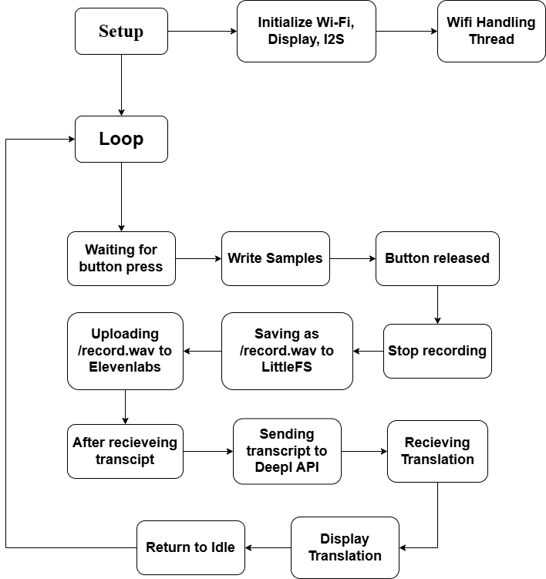
Serial Log Example:
[System] Recording started...
[System] Recording stopped.
[System] Processing audio...
[Result] Translated: "The system is ready."

Summary for software
The software architecture efficiently integrates hardware drivers, network communication, and cloud services into a single embedded system.
Each module is functionally independent and communicates through clear interfaces managed by the main program.
The final implementation successfully performs speech recording, cloud-based transcription, and translation with stable performance and accurate results.

Results
The final prototype of the Speech-to-Text Translation System worked as intended.
It successfully recorded speech, recognized it through the ElevenLabs API, translated the text using DeepL, and displayed the final translation on the TFT screen.
All hardware modules performed reliably: the INMP441 microphone provided clean audio, and LittleFS handled local WAV storage without issues. The ESP32 maintained a stable Wi-Fi connection thanks to the background FreeRTOS task, which kept the system online during the entire process.
Overall, the device operated smoothly and delivered accurate translations in several languages, showing that the ESP32 can handle cloud-based speech recognition and translation efficiently.

Discussion

General Evaluation
The Speech-to-Text Translation System based on the ESP32 microcontroller achieved its main goal — recording speech, converting it to text, translating it, and displaying the final output.
All core functions worked reliably, and the system operated without crashes or instability. The integration of hardware and software modules resulted in a compact, responsive, and easy-to-use device that successfully met the initial design objectives.

Design Decisions
The modular design of the system worked very well.
Each part — microphone, recorder, Wi-Fi, translator, and display — had its own clear function.
The ESP32 was powerful enough to record audio and send data to cloud services at the same time.
The INMP441 microphone provided clean sound, and LittleFS allowed fast and reliable file storage inside the microcontroller.
Using cloud services such as ElevenLabs and DeepL gave high accuracy for both recognition and translation, making this approach the best choice for a small embedded device.
The project also includes a local web server, which lets the user connect to the ESP32 through its local IP address to download or listen to recordings.
This made the system more practical and user-friendly, allowing anyone to check the audio directly from a phone or computer without extra hardware.

System Performance and Stability
The system was stable during all operations.
At the beginning of testing, some recordings had noise and speed problems caused by incorrect I²S settings and data conversion.
After fixing the configuration and sample alignment, the sound became clean and natural.
The FreeRTOS task kept the Wi-Fi connection active in the background, and this made cloud requests reliable without affecting other parts of the program.

Limitations
The system needs an internet connection for recognition and translation.
The processing time depends on the network speed and server response.
Also, the recording length is limited by the internal memory size of the ESP32, which makes very long recordings impossible.

Future Improvements
Future updates could focus on improving the user interface — for example, adding a way to choose the translation language from the display or showing short logs of past translations.
It may also be useful to improve error messages or add indicators for Wi-Fi connection and processing status.

Conclusion

The Speech-to-Text Translation System was successfully designed and tested.
It can record voice, recognize spoken words using the ElevenLabs API, translate them through DeepL, and show the final text on the display.
All parts of the system worked together smoothly and proved that the ESP32 microcontroller can handle both audio processing and cloud communication efficiently.
The project showed that a small and low-cost device can perform complex language tasks when combined with cloud services.
The use of modular software made the code easier to understand, improve, and test.
The added local web server also made the device more practical, allowing users to listen to recordings directly through a browser.
In general, the system met all design goals and demonstrated a reliable, simple, and functional solution for speech recognition and translation on an embedded platform.
This project can serve as a strong base for future work in voice-controlled or multilingual embedded devices.
QR Code: Link to GitHub Project

